USDA GUIDANCE

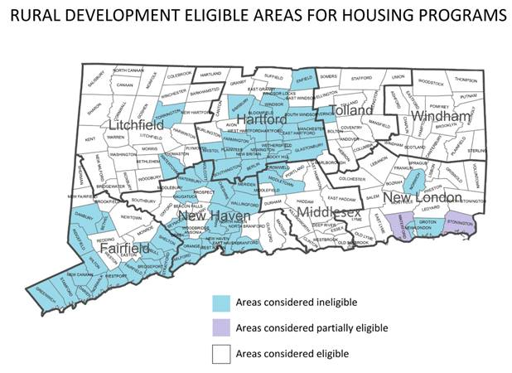

* If the borrower already has a loan directly from USDA, they are encouraged to reach out to USDA to determine if there are any servicing options available.  Servicing options are likely to include some combination of subsequent loans, protective advances, workout agreements and re-amortization.
* If the borrower has a loan through a lender that is guaranteed by USDA, lenders are encouraged to reach out to USDA to determine if there are prudent servicing measures that USDA can allow and still maintain the full benefit of the guarantee agreement.
* Very low income homeowners over 62 years of age can reach out to USDA for repair grants of up to $7,500.
* Very low income homeowners of any age can reach out to USDA for a repair loan of up to $20,000.
* Low income homeowners may be able to refinance their existing non-USDA loan if their home is in danger of foreclosure or is becoming unsuitable for habitation due to a crumbling foundation.